**Chapter 14: International Trade**

**Free trade:**

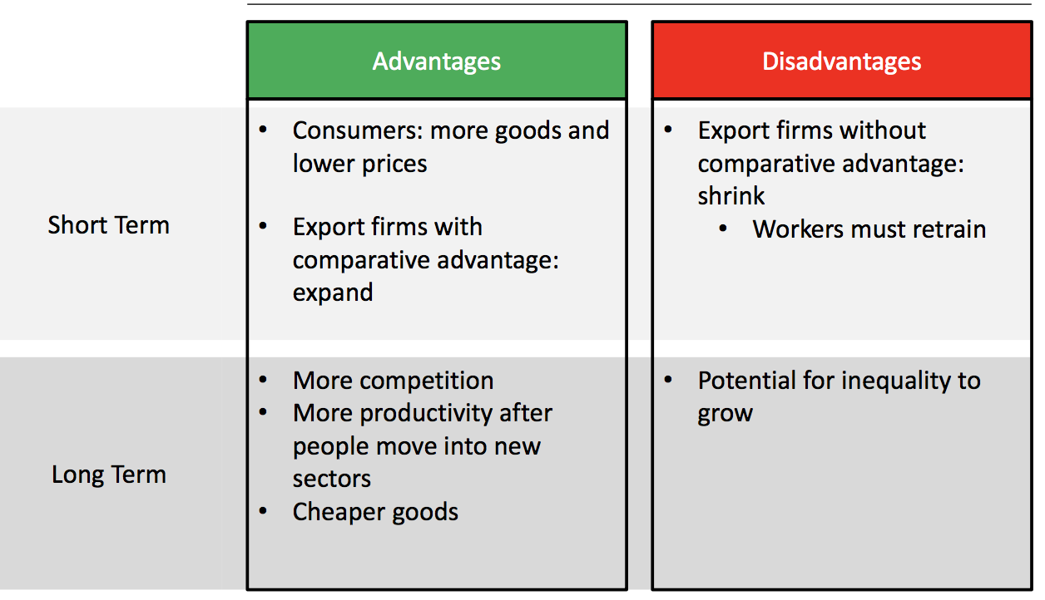

**Production Possibilities Curve**

* The Production Possibilities Curve (PPC) describes the trade-off between producing one good or another:

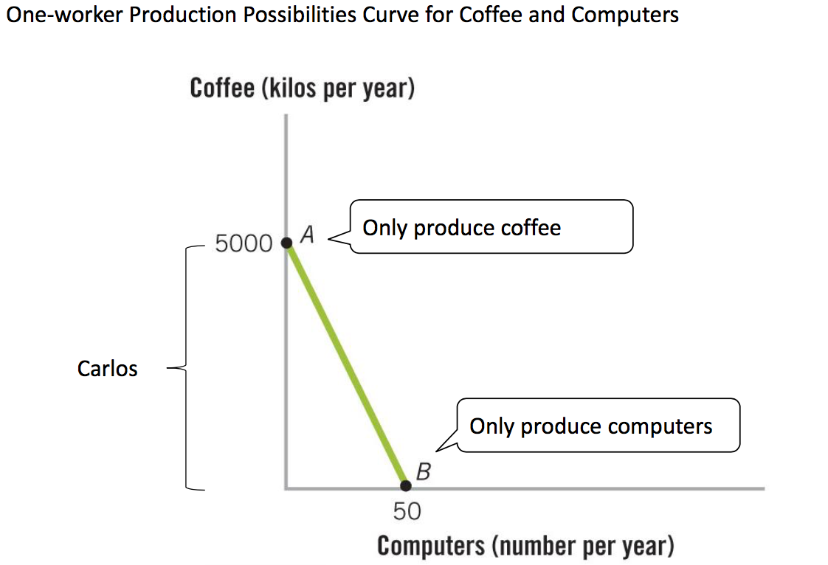

* The PPC can describe the trade-offs of many workers, who we rank by their comparative advantage in each good (the slope of the curve):
* 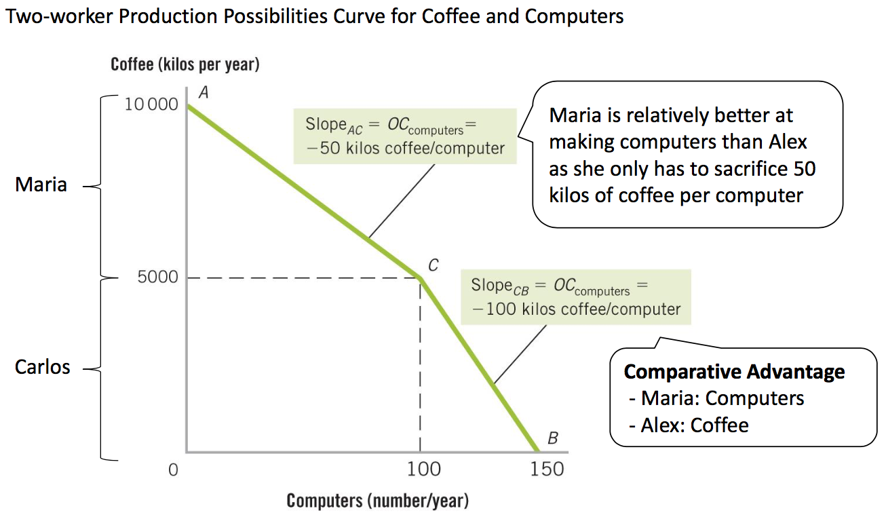
* When we want to produce computers we start by using workers with the largest comparative advantage:

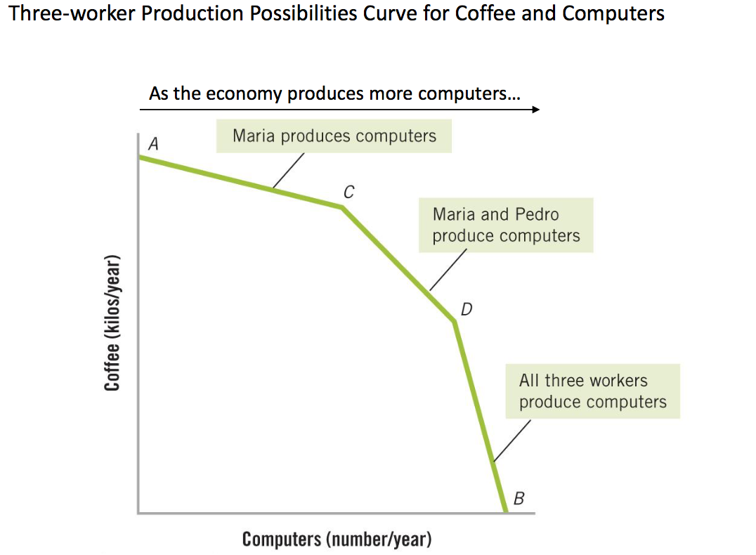

* If the economy has a large number of workers then the PPC becomes smooth:

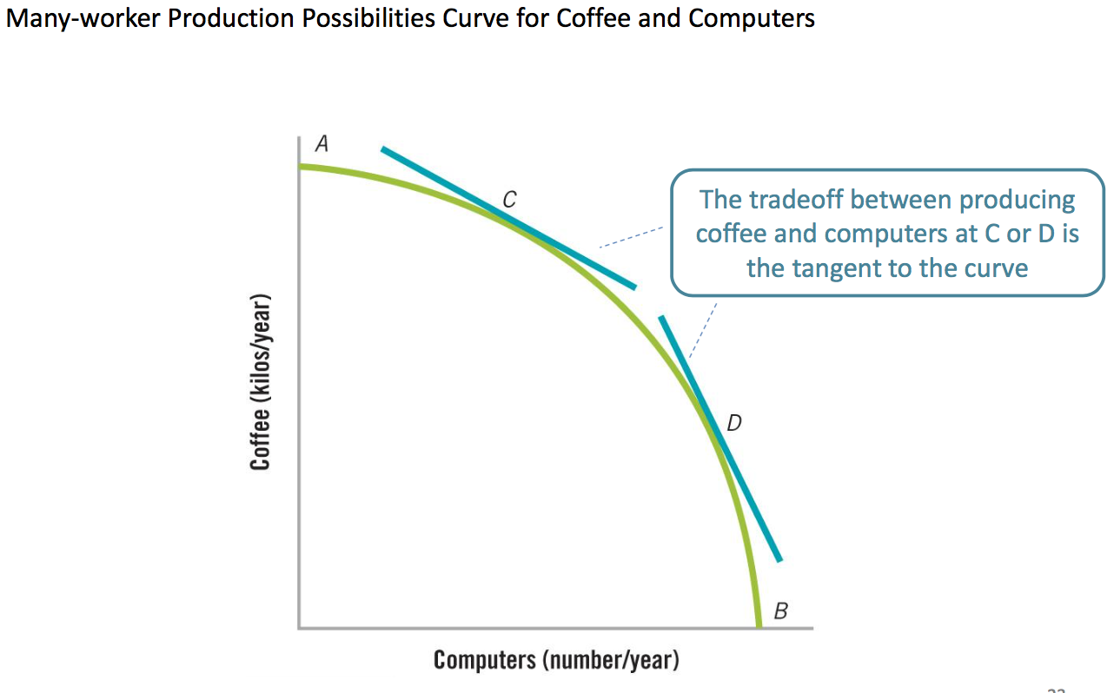

* If the economy is closed to trade (called “autarky”), then it can only consume what it produces. Some combinations will be “unattainable”.

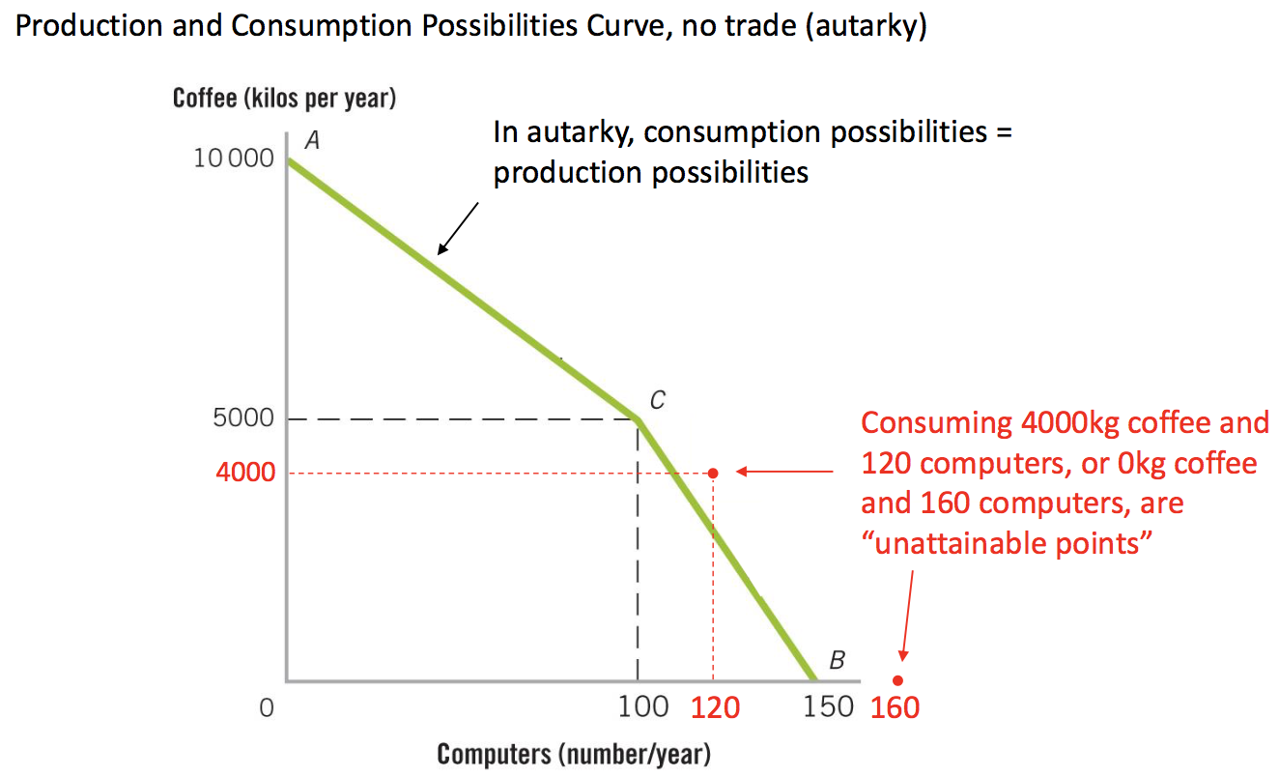

* If the economy is open to trade, then it can produce based on comparative advantage, and trade to increase consumption possibilities:

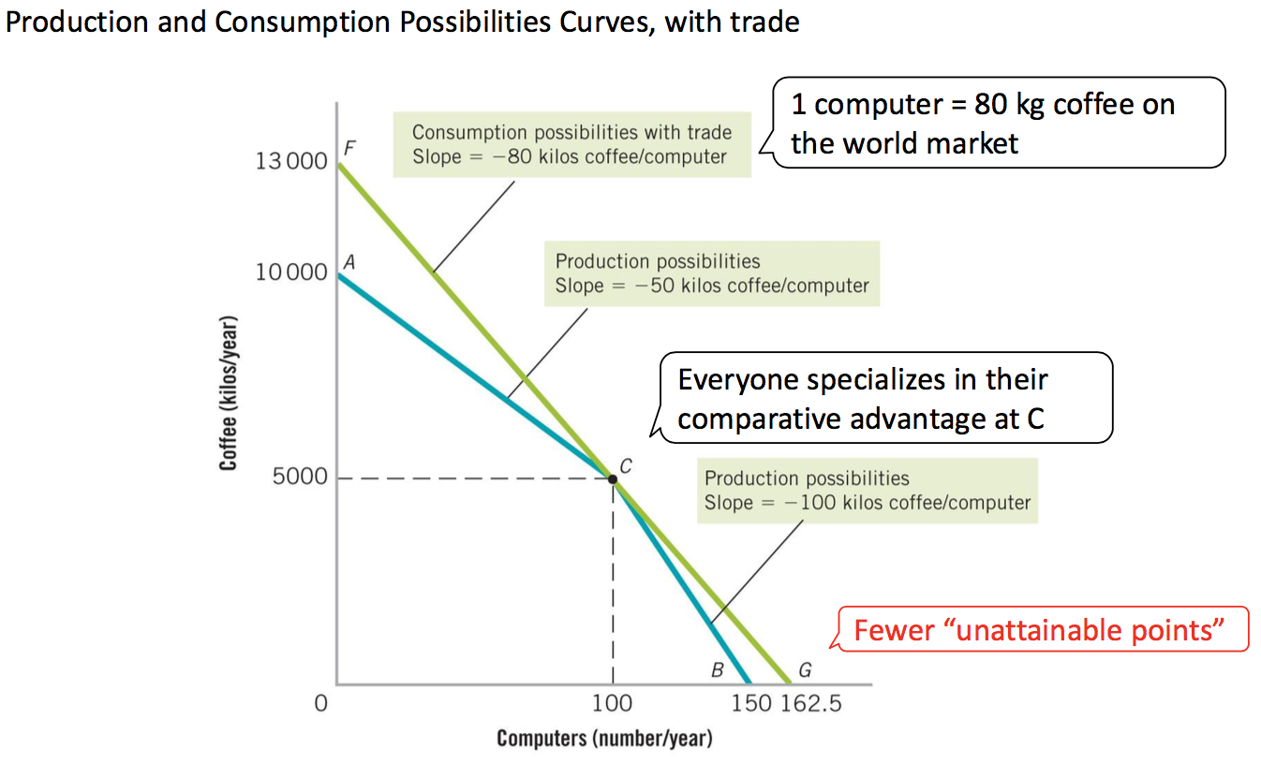

* In a large economy, with workers that have widely varying comparative advantages, the gains from trade are even bigger:

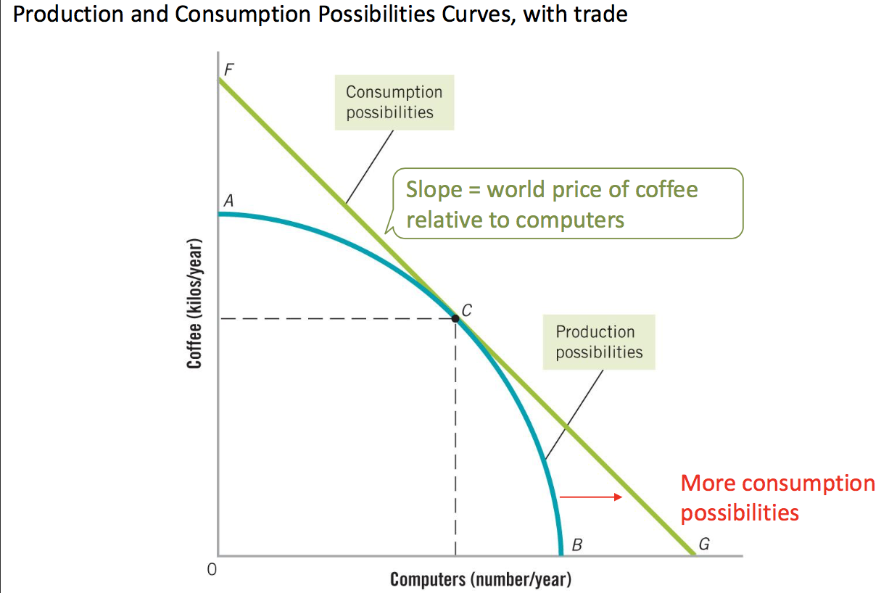

* Countries overall also have different comparative advantages. Brazil has a comparative advantage over Korea in coffee relative to computers:

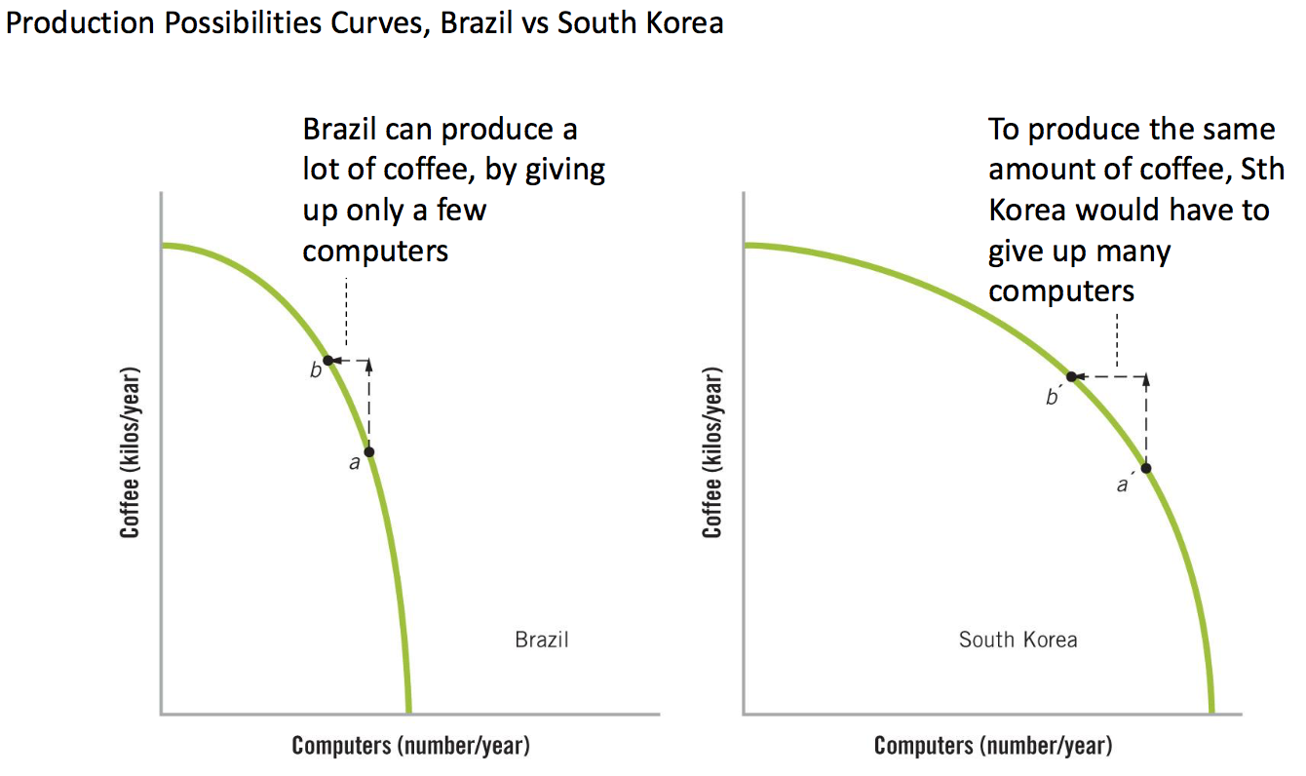

* In autarky each country is restricted to consuming only what they produce, while under free trade each country can exchange what they produce at the world price, increase consumption opportunities for both:

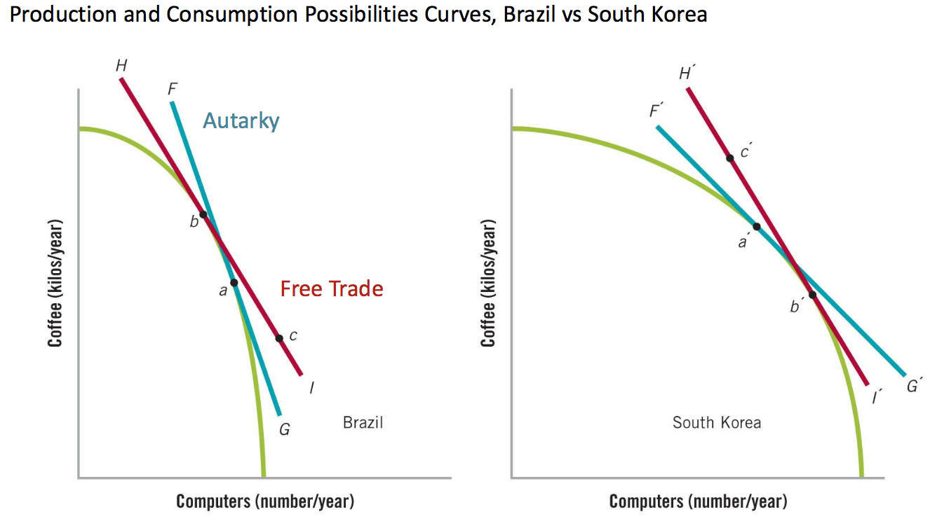

* Comparative advantage comes from the relative endowment of land, labour, capital and tech (“Production factors”) in each country.

**Individual goods: Supply and Demand**

* As Brazil had a comparative advantage in producing coffee and it can produce coffee relatively easily compared to other places, the world price will be higher than domestic equilibrium under free trade:

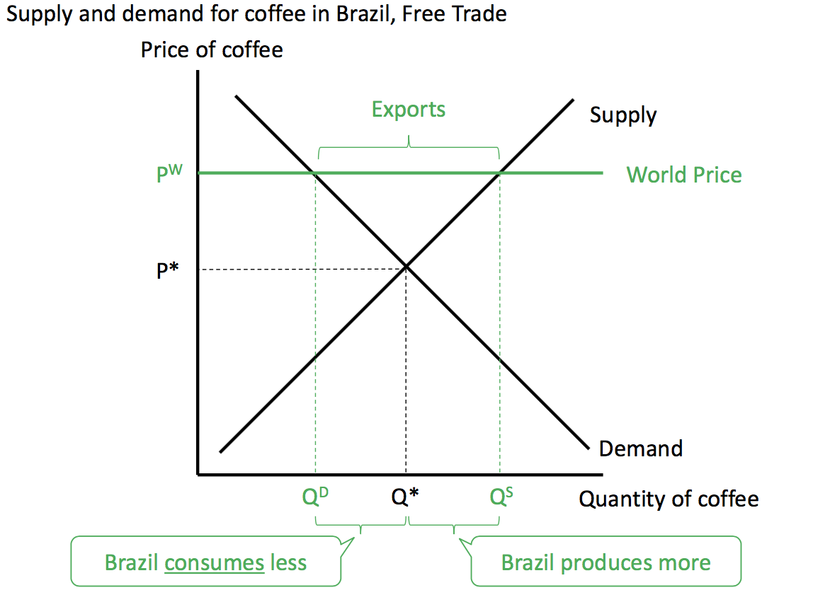

* The opposite will happen with computers. Brazil will produce fewer computers, but consume more of them:

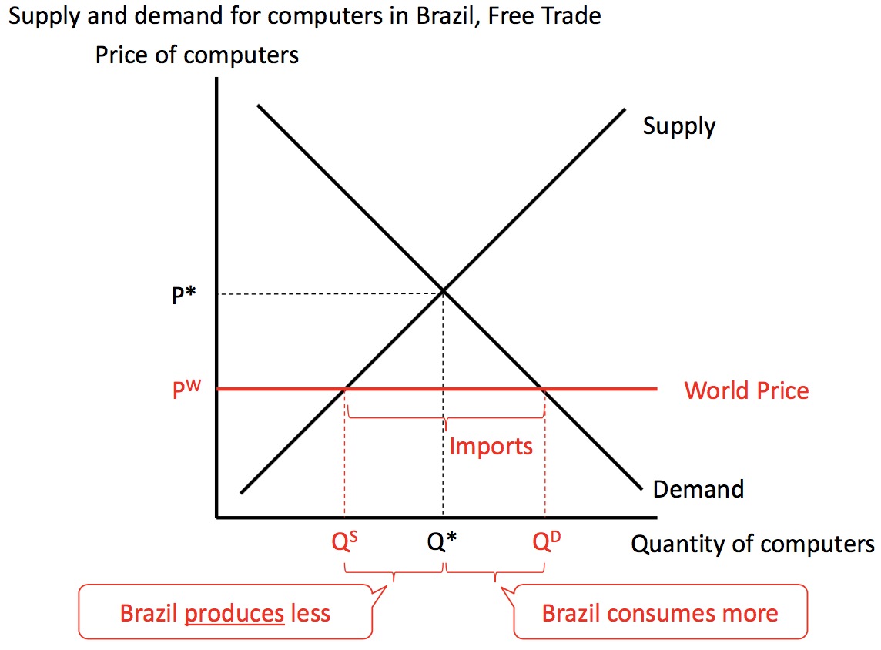

* Free trade benefits the domestic consumers of imported goods (world price lower) and domestic producers of exported goods (world price higher).
* While free trade increases the size of the pie, the slices are not shared equally. Some people benefit more than others.

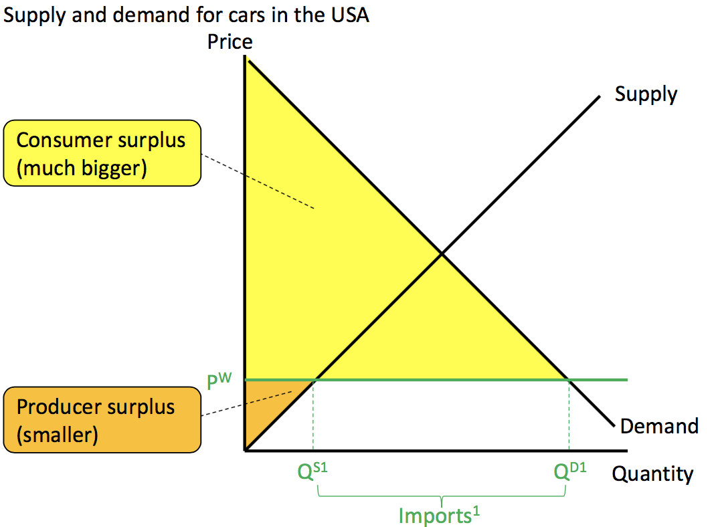**Protectionism: Tariffs and quotas**

Free trade: there is a large increase in total surplus because of a big increases in consumer surplus, while producer surplus falls:

Consumer and producer surplus if there is no trade at all:

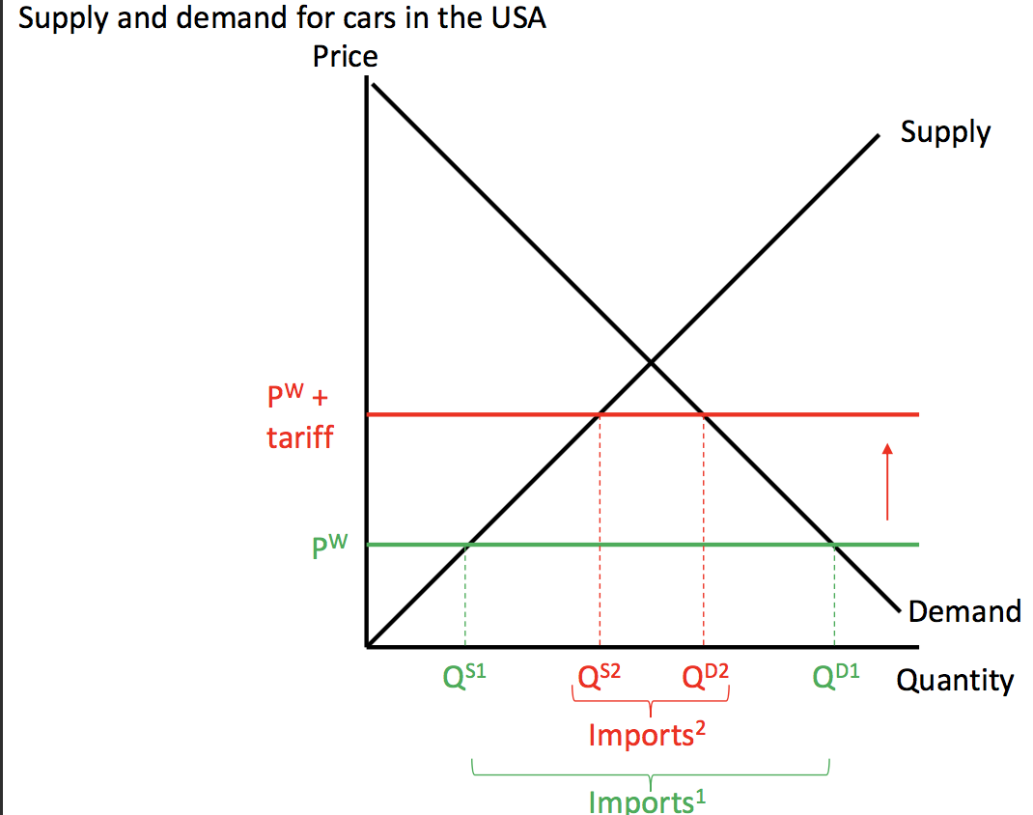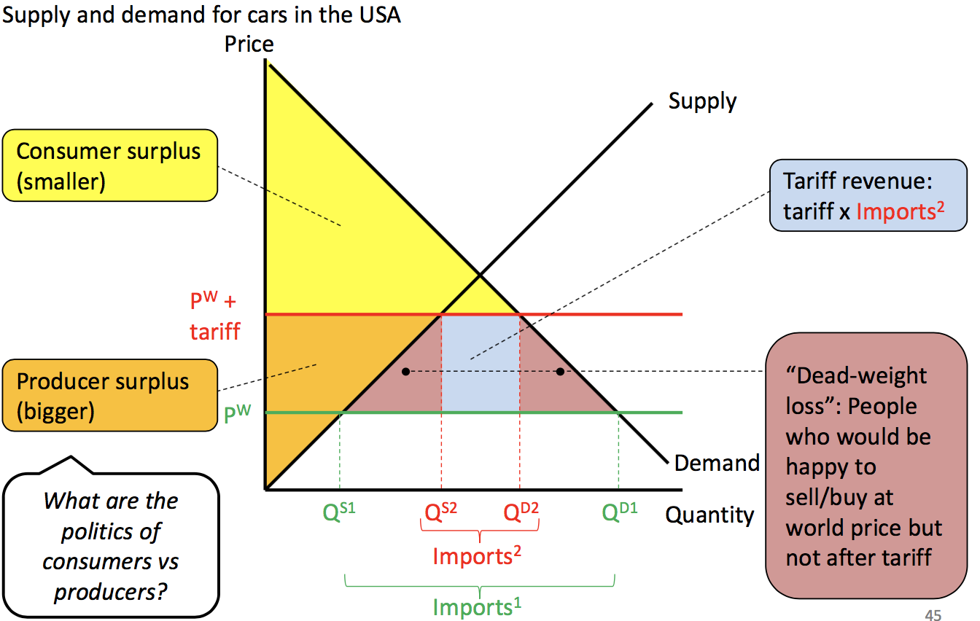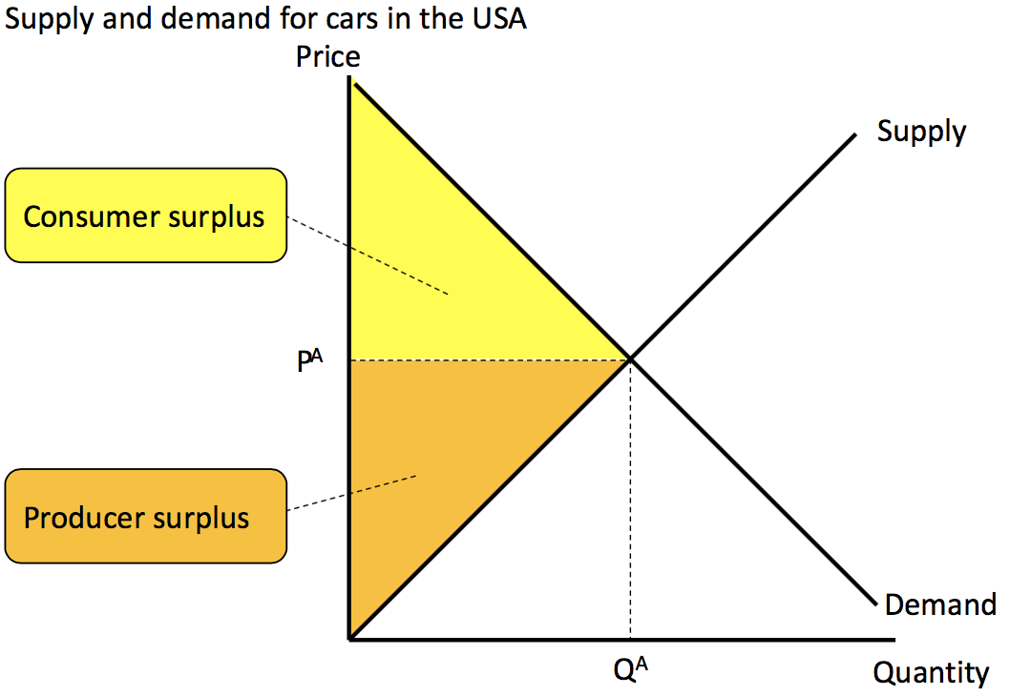

**Tariffs** raise the local price of goods – hurting consumers, and reduce imports – helping producers

Tariffs reduce consumer surplus, increase producer surplus, raise gov't revenue and create a "**deadweight loss".**

* **Quotas** limit the amount of goods supplied by imports. Like a tariff it raises the local price, hurting consumers and helping producers:

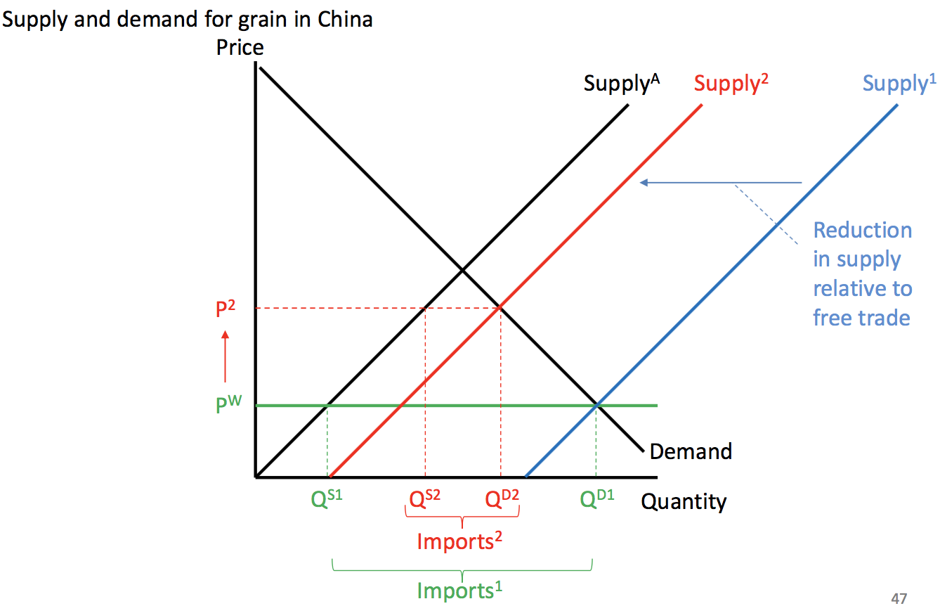

* Quotas also create a deadweight loss relative to free trade: 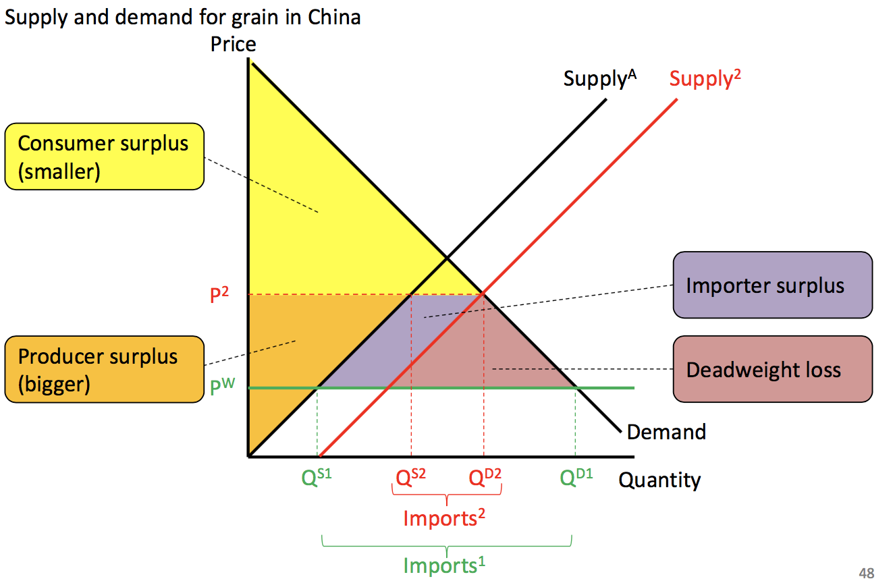
* Both tariffs and quotas are bad but tariffs are better than quotas as the revenue goes to the gov’t, which can be redistributed, rather than import license owners:

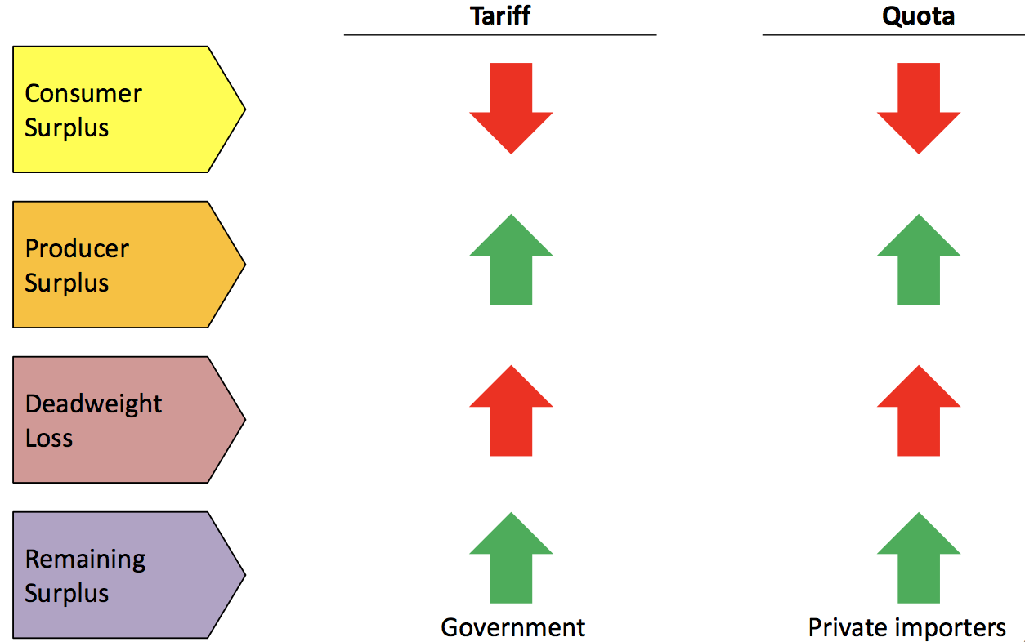

* The deadweight loss means that protectionism (tariffs and quotas) shrink the overall size of the pie:

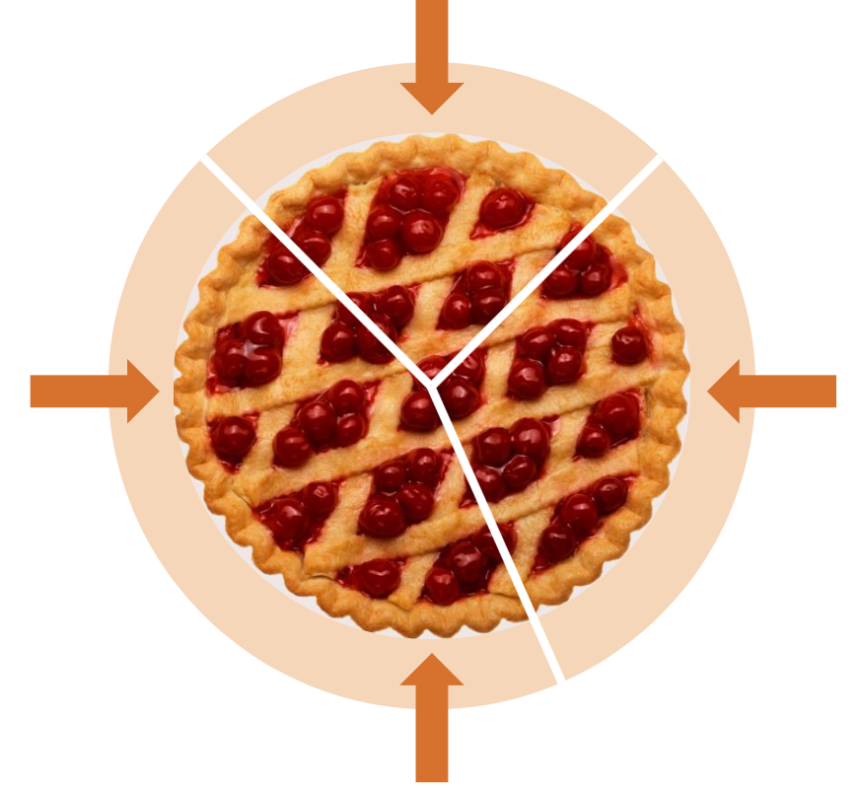 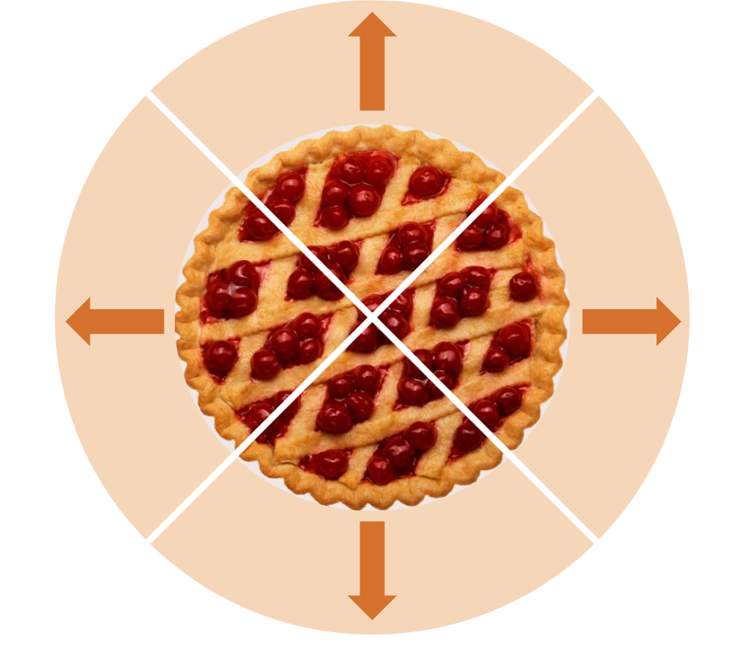

* It is better to use free trade to increase the size of the pie, and then use fiscal policy to share proceeds by compensating the losers. (right graph)

**Summary:**

* A nation’s PPC summarises the available points of efficient production by showing, when holding the production of all other commodities fixed, what is the maximum amount of a commodity than can be produced.
* In autarky, the consumption set comprises only those combinations of goods that can be produced.
* Under free trade, it is possible that the consumption set is expanded beyond what can be produced locally.
* There are always winners and losers from free trade.
* Protectionist measures such as tariffs and quotas can be justified if the winders are willing and able to compensate the losers.
* Empirical studies suggest that the free trade-environment nexus is complex, through most findings agree that pollutions is lower in rich, open countries.

**Chapter 15: Exchange rates and the open economy**

**Nominal exchange rates**

* The nominal exchange rate is the amount of one currency that people are willing to exchange for another.
* Each exchange rate are typically quoted as a pair, describing the price of one unit of the base currency in terms of the other. Treat the base currency like a loaf of bread.

Eg. USD 0.76 = AUD 1.00 (base currency)

USD 1.00 (base currency) = AUD 1.32

* If the base currency is worth more, then it “appreciates”, if it is worth less, then it “depreciates”

**Real exchange rate**

* The real exchange rate (RER) is the ratio of the domestic price level to the foreign price level converted to domestic dollar. 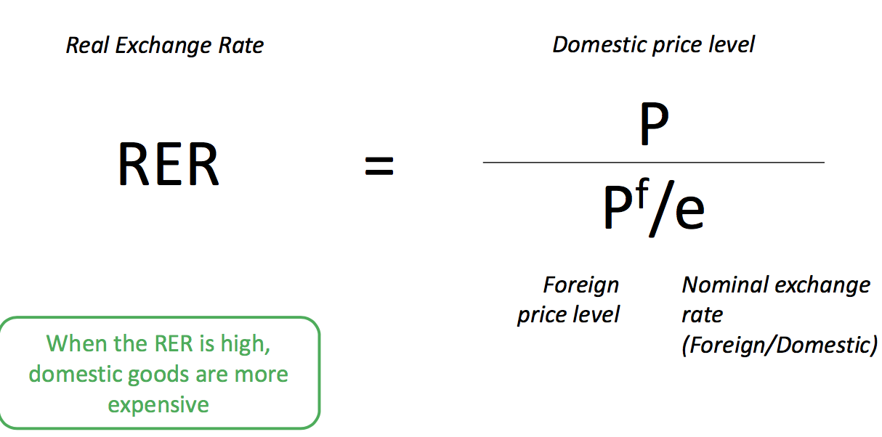
* Eg. An Australian-made computer costs 2400AUD and a very similar Japanese computer costs 242000 yen. The exchange rate is 110 yen = 1AUD
* RER = 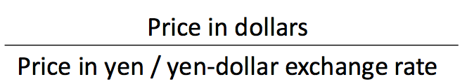

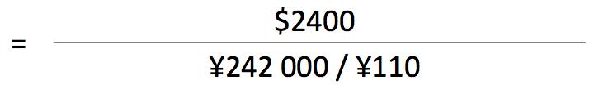

= 1.09

Therefore, computer that produced in Australia is more expensive.

* Big Mac Index is used to compare the real exchange rate across countries.
* Law of One Price says that in the long run, the price of internationally traded goods should be the same everywhere (RER = 1) because otherwise you could buy a burger in the US and sell it in Australia and profit.
* “Purchasing power parity” is the theory that the nominal exchange rate will adjust so that the law of one price holds.

Eg.